11.4 Contact process
Name: ____________________ Class: ____________________ Due date: 11.23
1 .Which row shows the conditions used in the manufacture of sulfuric acid by the Contact process? （ ）
 | temperature /℃ | pressure /atm | catalyst
A | 40 | 200 | Fe
B | 40 | 200 | V2O₅
C | 400 | 2 | Fe
D | 400 | 2 | V2O₅

2. The following reaction has reached equilibrium in a closed system.
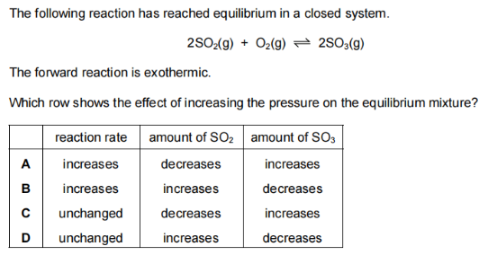
The forward reaction is exothermic.
Which row shows the effect of increasing pressure on the equilibrium mixture?（ ）
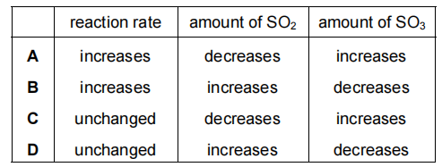
${SO}_{2}$3. Sulfur dioxide, , is used in the manufacture of sulfuric acid.
a.In the first stage of the process, sulfur dioxide is obtained from sulfur-containing ores.
Name one of these ores.
..................................................................................................................................
b.The next stage of the process is a reaction which can reach equilibrium. The equation for this stage is shown.
$$2{SO}_{2}(g)+O_{2}(g)⇌2{SO}_{3}(g)$$
i.Describe two features of an equilibrium................................................................ [2]
ii.Name the catalyst used in this stage..................................................................... [1]
iii.Why is a catalyst used? ..........................................................................................[1]
iv.Explain, in terms of particles, why a high temperature increases the rate of this reaction.
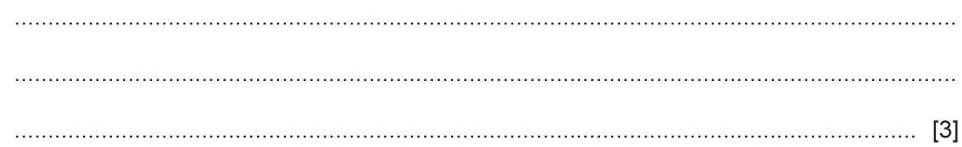
${450}^{∘}C$In this stage, only a moderate temperature of is used.
What does this suggest about the forward reaction?
.......................................................................................................................................
..................................................................................................................................[1]
c.Concentrated sulfuric acid is a dehydrating agent which can chemically remove water from substances.
Sulfuric acid is manufactured using the Contact process.
This manufacture involves four stages.
Stage 1 involves the combustion of sulfur to form sulfur dioxide.
Write the chemical equation for stage 1.
...................................................................................................................................[1]
ii.The equation for stage 2 is shown.
$$2{SO}_{2}(g)+O_{2}(g)⇌2{SO}_{3}(g)$$
The reaction can reach equilibrium.
${SO}_{3}$$H_{2}S_{2}O_{7}$d.In stage 3 sulfur trioxide, , is converted to oleum, .
$H_{2}{SO}_{4}$In stage 4 oleum reacts to form sulfuric acid, .
State what oleum reacts with in stage 4.
.......................................................................................................................................
.......................................................................................................................................
3 (a) Sulfuric acid is made from sulfur in a four-stage process.
stage 1 Sulfur is converted into sulfur dioxide.
stage 2 Sulfur dioxide is converted into sulfur trioxide.
stage 3 Sulfur trioxide is converted into oleum.
stage 4 Oleum is converted into sulfuric acid.
How is sulfur converted into sulfur dioxide in stage 1?
..................................................................................................................................
.................................................................................................................................[1]
Describe how sulfur dioxide is converted into sulfur trioxide in stage 2.
Your answer should include:
an equation for the reaction
the temperature used
the name of the catalyst used.
..................................................................................................................................
..................................................................................................................................
$H_{2}S_{2}O_{7}$Sulfur trioxide is converted into oleum, in stage 3.
What is sulfur trioxide reacted with to convert it into oleum?
..................................................................................................................................[1]
Sulfur dioxide, SO₂, is used in the manufacture of sulfuric acid
(a) in the first stage of the process, sulfur dioxide is obtained from sulfur-containing ores.Name one of these ores.
(b) The next stage of the process is a reaction which can reach equilibrum.
The equation for this stage is shown.
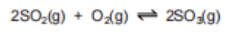
(i) Name the catalyst used in this stage..................................................
(il) why is a catalyst used?
..................................................................................................................................
..................................................................................................................................

